**ASSIGNMENT-1(NALAIYA THIRAN)**

**SMART HOME DESIGN USING TINKERCAD**

**TEAM MEMBER-2: D.Prem**

**REGISTER NUMBER:720319106016**

**SCHEMATIC(CIRCUIT DIAGRAM)**

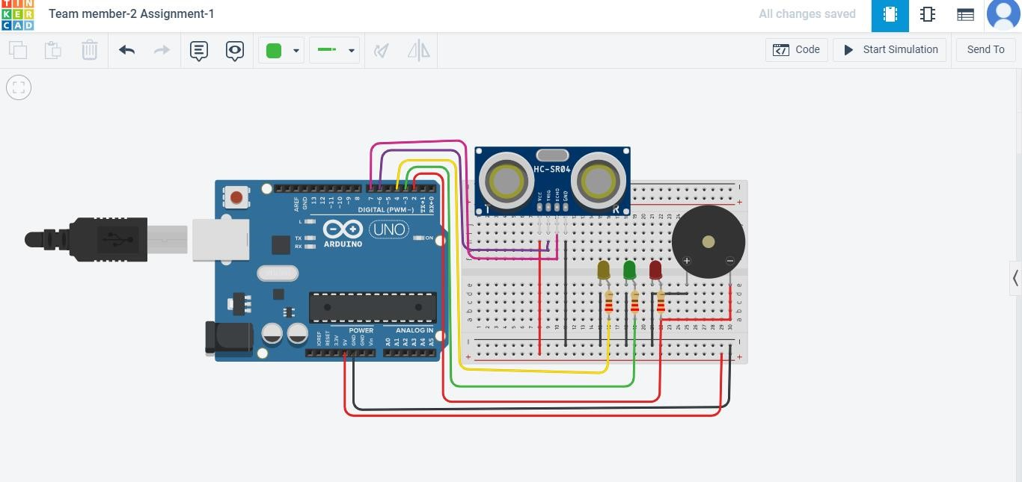

**CODE:-(PROGRAM)**

int distance = 0; int cm = 0; long readUltrasonicDistance(int triggerPin, int echoPin)

{

pinMode(triggerPin, OUTPUT); // Clear the trigger digitalWrite(triggerPin, LOW); delayMicroseconds(2);

digitalWrite(triggerPin, HIGH); delayMicroseconds(10); digitalWrite(triggerPin, LOW); pinMode(echoPin, INPUT); return pulseIn(echoPin, HIGH);

}

void setup()

{

Serial.begin(9600); pinMode(2, OUTPUT); pinMode(3, OUTPUT); pinMode(4, OUTPUT);

}

void loop()

{

distance = 330; cm = 0.01723 * readUltrasonicDistance(6, 7);

Serial.print(cm); Serial.println("cm"); if (cm > distance) { digitalWrite(2, LOW); digitalWrite(3, LOW); digitalWrite(4, LOW);

} else { if (cm > 230) { digitalWrite(2, LOW); digitalWrite(3, LOW); digitalWrite(4, HIGH);

} else { if (cm > 100) { digitalWrite(2, LOW); digitalWrite(3, HIGH); digitalWrite(4, LOW);

} else { if (cm > 1) { digitalWrite(2, HIGH); digitalWrite(3, LOW); digitalWrite(4, LOW);

} else { digitalWrite(2, LOW); digitalWrite(3, LOW); digitalWrite(4, LOW);

}

}

}

}

delay(100); }